Screenshots or demo link of Tic-Tac-Toe game using HTML, CSS, and JavaScript
Demo link:
tic-tac-toe-rithika.netlify.app
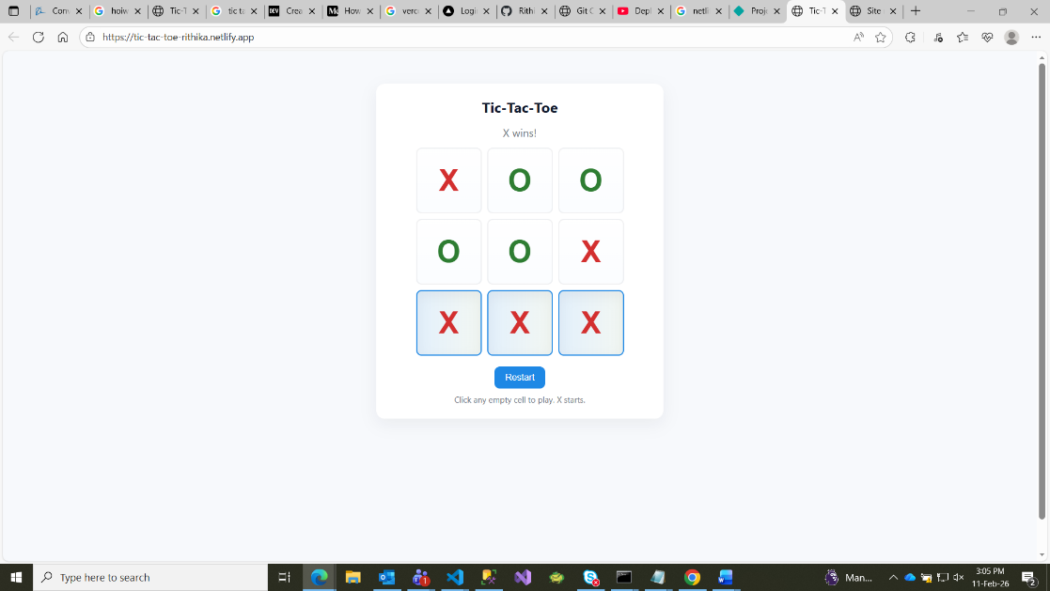
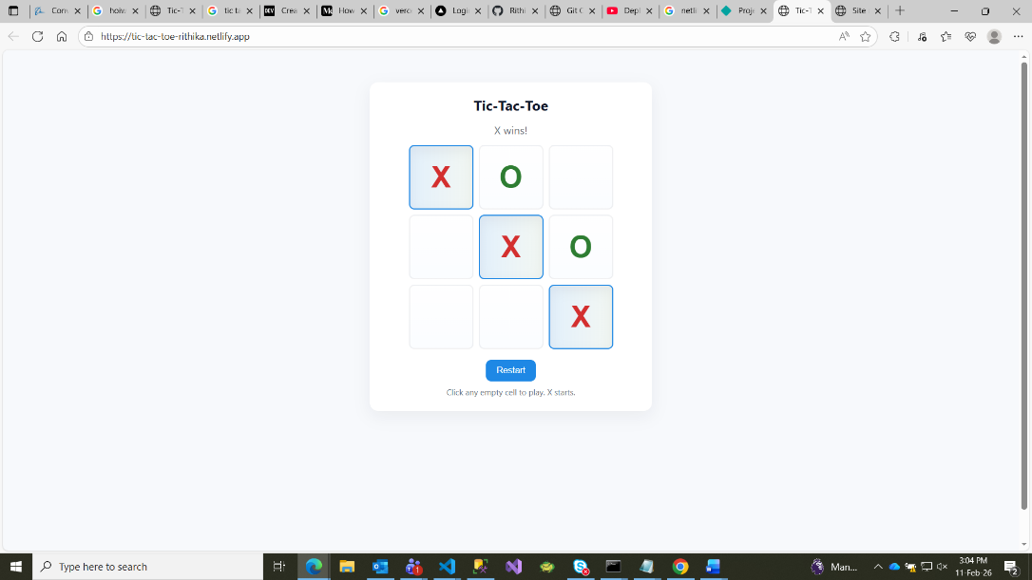
Screenshots:

